# Promoted Brands/Display Create flow - Content Documentation

# ****Create new campaign - Content****

|  |  |  |  |  |
| --- | --- | --- | --- | --- |
| **Position/Relevance** | **#** | **Mock Content** | **Final Content** | **Notes** |
| Top Header | 1 | Promoted Listings Advanced | Promoted Listings Advanced |  |
| Header | 2 | Create new campaign | Create new campaign | Create new campaign |
| Main Heading | 3 | Name your campaign and set your budget | Name your campaign and set your budget |  |
| Field Title 1 | 3a | Campaign name | Campaign name |  |
| Field Title 2 | 3b | Start date | Start date |  |
| Field Title 3 | 3c | End date | End date |  |
| Field Title 4 | 3d | Daily budget | Daily budget |  |
| Info bubble (Daily budget) | 3e | Daily budget is the maximum dollar amount that you are willing to spend on a single campaign per day.  Some days you may spend less than your daily budget, but you will never be charged more than the amount you enter.  Once your keywords have received enough clicks to reach your daily budget, your CPC campaign will pause until the next day, when the daily budget resets.  Sales will be attributed within a 7-day window of a click on your ad and are based on a first click attribution model. | Daily budget is the maximum dollar amount that you are willing to spend on a single campaign per day.  Some days you may spend less than your daily budget, but you will never be charged more than the amount you enter.  Once your keywords have received enough clicks to reach your daily budget, your campaign will stop being charged until the next day, when your daily budget resets.  As a reminder, this campaign is based on a cost-per-click model, and sales will be attributed within a 7-day window of a click on your ad. | Unknown User (vlotz)4.9.21  Rashid, Tasmiah |
| Ghost text (Daily budget) | 3F | $1.00 min | $1.00 min | Ghost text |
| Campaign name character limit | 3G | "x"/80 | "x"/80 | The first number is variable based on the character entered by the user |
| Minimum daily budget limit | 3H | 1.00 minimum | 1.00 minimum |  |

# ****Create new campaign - Image****

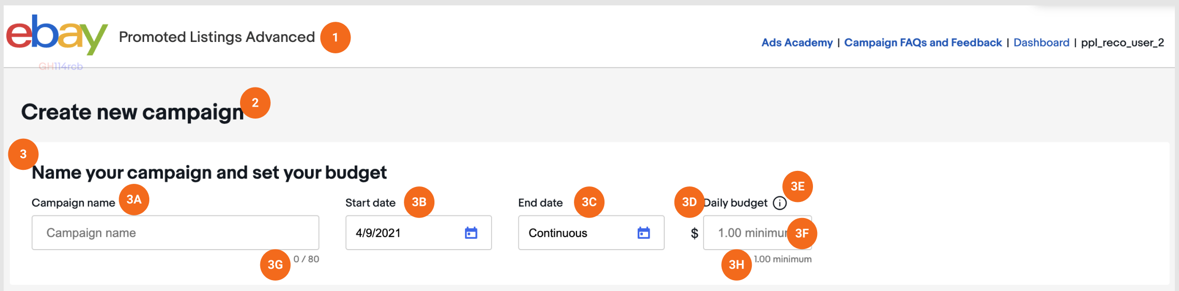

# ****Create your ad group Content (top - name and listing section)****

|  |  |  |  |  |
| --- | --- | --- | --- | --- |
| **Position/Relevance** | **#** | **Mock Content** | **Final Content** | **Notes** |
| Main Heading | 1 | Create your ad group | Create your ad group |  |
| Title Field 1 | 2A | Ad group name | Ad group name |  |
| Info bubble (Ad group name) | 2B | Ad groups help you build more effective campaigns by organizing your ads by a common goal or category. Grouping together similar listings allows you to target them with the same set of keywords.  For example, you might want to create an ad group containing men’s sneakers that you would like to promote for Father’s Day. | Ad groups help you build more effective campaigns by organizing your listings by a common goal or category. Grouping together similar listings allows you to target them with the same set of keywords. |  |
| Section Title | 3A | Select listings | Select your listings | Unknown User (vlotz)4.9.21 |
| Title Field 2 | 3b | Categories | Categories |  |
| Title Field 3 | 3C | Price | Price |  |
| Hyper Link | 3D | Reset all | Reset all | Link leads to warning pop up |
| Warning (Reset all) | 3D | Are you sure? Resetting filters will clear all listings selections you have made. | Are you sure? Resetting filters will clear all of your listings selections. | Pop up:    (<https://wiki.vip.corp.ebay.com/x/YRIKN>) |
| CTA 1 | 3E | Review listings | Mange listings |  |
| Variable Listing Information | 3F | **"x" listings selected** (of "x" available) | **"x" listings selected** (of "x" eligible) | The number of listings selected should reflected |

# ****Create your ad group Image (top - name and listing section)****

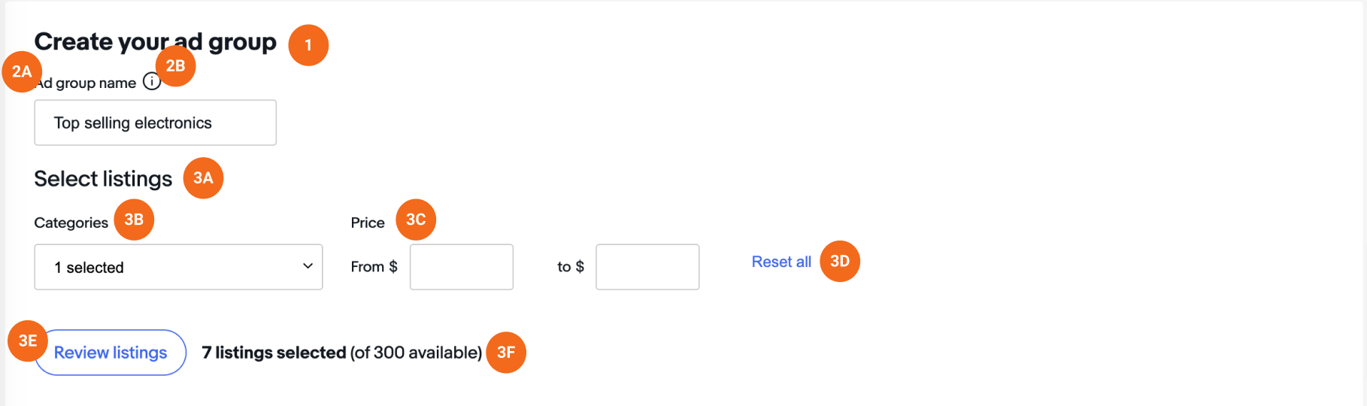

# ****Choose your keywords Content****

|  |  |  |  |  |
| --- | --- | --- | --- | --- |
| **Position/Relevance** | **#** | **Mock Content** | **Final Content** | **Notes** |
| Section Title | 1A | Choose your keywords | Choose your keywords |  |
| Subtitle | 1B | Suggested ("x") | Suggested ("x") | Unknown User (lcincinnato) |
| Info Bubble (suggested) | 1C | Suggested keywords are buyer search terms that are likely to be relevant for the listings in your ad group based on recent search history. | Suggested keywords are buyer search terms that are likely to be relevant for the listings in your ad group based on recent search history. |  |
| Chart Subtitle 2 | 1D | Custom | Custom |  |
| Info Bubble (Custom) | 1E | Keyword cannot exceed 80 characters or 10 words and cannot include special characters (!=?@%^*;~`,(){}<>|). Keywords must be separated by a new line. | You may add a custom selection of keywords that you have determined are relevant to the listings in your ad group.  Keywords must be in a separate line, and cannot include special characters (!=?@%^*;~`,(){}<>|), or exceed 80 characters or 10 words. | Text to go in the body of the Choose your keywords section under the Add your own/Custom tab  Unknown User (vlotz)4.9.21 |
| Chart Subtitle 3 | 1F | Match types include suggested bid ranges | Match types include suggested bid ranges | Unknown User (lcincinnato) |
| Ghost Text (Search keywords) | 1G | Search keywords | Search keywords | Ghost text |
| Info Bubble (Match types include suggested bid ranges) | 1H | The suggested bid range is based on what other advertisers have used for a specific keyword.  To suggest a bid range, eBay aggregates bids that have recently received clicks in the top of the search results page.  Please note that we may not provide a suggested bid range for all custom keywords. | The suggested bid range is based on what other advertisers have used for a specific keyword.  To suggest a bid range, eBay aggregates bids that have recently received clicks in the top of the search results page.  Please note that we may not provide a suggested bid range for all custom keywords. |  |
| Chart Column Header 1 | 1I | Keywords | Keywords | Unknown User (lcincinnato) |
| Chart Column Header 2 | 1J | Exact match | Exact match | Unknown User (vlotz) 4.9.21 |
| Info Bubble (exact match) | 1K | Exact match means that your ads will only appear for searches that match your exact keyword or close variants.  Close variants may include synonyms, plurals and search terms with slightly different spelling. | Exact match means that your ads will only appear for searches that match your exact keyword or close variants.  Close variants may include synonyms, plurals and search terms with slightly different spelling. | Unknown User (lcincinnato) |
| CTA 2 | 1L | Add keywords | Add keywords |  |
| Ghost text for Custom keyword entry | 1M | Add a custom selection of keywords that are relevant to the listings you have selected by typing or pasting them here. Keywords must be in a separate line. | Add a custom selection of keywords that are relevant to the listings you have selected by typing or pasting them here. Keywords must be in a separate line. | Ghost text |

# ****Choose your keywords Image****

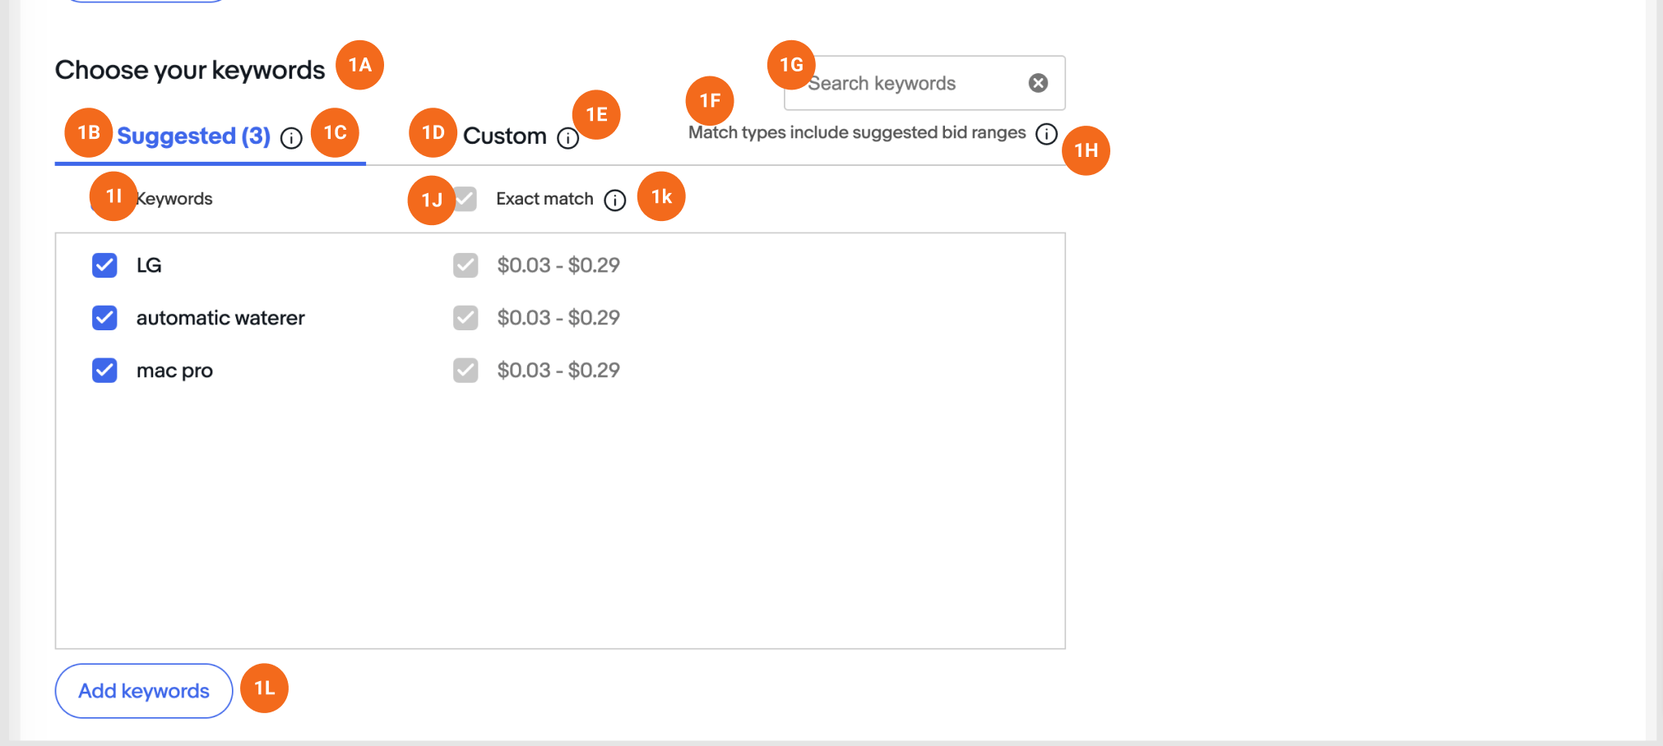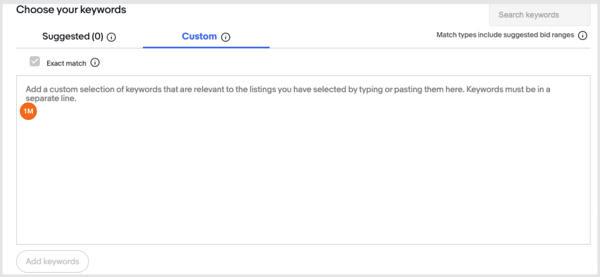

# ****Set CPC bids for your keywords - Content****

|  |  |  |  |  |
| --- | --- | --- | --- | --- |
| **Position/Relevance** | **#** | **Mock Content** | **Final Content** | **Notes** |
| Section Title | 1A | Set CPC bids for your keywords ("x") | Set CPC bids for your keywords ("x") |  |
| Search Box | 1B | Search keywords | Search keywords | Ghost Text |
| Chart Column 1 | 1C | Keywords | Keywords |  |
| Chart Column 2 | 1D | Match type | Match type |  |
| Chart Column 3 | 1E | Suggested bid | Suggested bid |  |
| Chart Column 4 | 1F | Your bid | Your bid |  |
| Info Bubble (suggested bid column) | 1G | The suggested bid range is based on what other advertisers have used for a specific keyword.  To suggest a bid range, eBay aggregates bids that have recently received clicks in the top of the search results page.  Please note that we may not provide a suggested bid range for all custom keywords. | The suggested bid range is based on what other advertisers have used for a specific keyword.  To suggest a bid range, eBay aggregates bids that have recently received clicks in the top of the search results page.  Please note that suggested bid range will be provided for most, but not all, custom keywords. |  |
| Info bubble (your bid column) |  |  |  |  |
| Cancel/Close Window | 1H | Cancel | Cancel |  |
| Approve Window Contents | 1I | Review | Review |  |

# ****Set CPC bids for your keywords - Image****

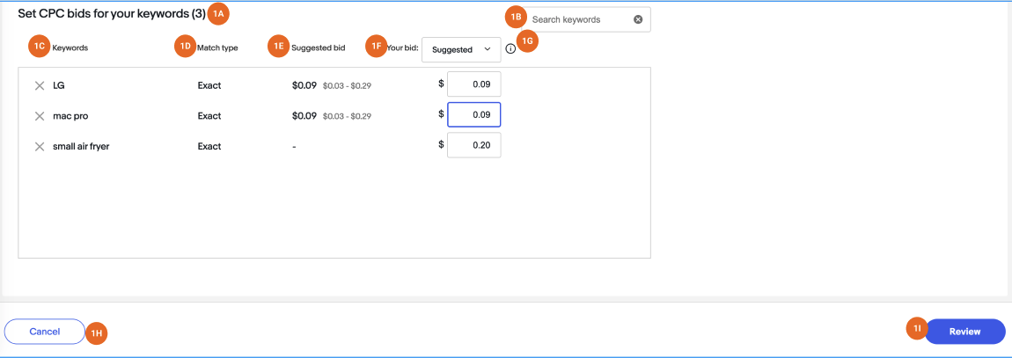

# ****Listing Grid - Content****

|  |  |  |  |  |
| --- | --- | --- | --- | --- |
| **Position/Relevance** | **#** | **Mock Content** | **Final Content** | **Notes** |
| Section Title | 1A | "x" listings selected (of "x" available) | "x" listings selected (of "x" available) |  |
| Categories | 1B | Categories | Categories |  |
| Price | 1C | Price | Price |  |
| Reset All | 1E | Reset all | Reset all |  |
| Chart Column 1 | 1F | Title | Title |  |
| Chart Column 2 | 1G | Price | Price |  |
| Chart Column 3 | 1H | Qty | Qty |  |
| Chart Column 4 | 1I | Search impressions (top 200) | Search impressions (top 200) |  |
| Chart Column 4 Info Bubble (Search impressions (top 200)) | 1J | The number of times your listings have appeared within slots 1 - 200 of the search results page in the past 30 days. Listings that have received impressions are more likely to perform well.  You can view the number of times a listing has appeared in the column below.  Listings that have appeared within slots 1 - 200 of the search results page in the last 30 days are more likely to perform well. | The number of times your listings have appeared within slots 1 - 200 of the search results page in the past 30 days.  Listings with search impressions are more likely to perform well. |  |
| Chart Column 5 | 1K | Listing age (days) | Listing age (days) |  |
| Chart Column 5 Info Bubble | 1L | Listing age is based on when the listing was created. | Listing age is based on when the listing was created. |  |
| **?** | **1M** | **Items** | **(remove)** | This does not serve a purpose and should be removed |
| Exit Window/Cancel Updates | 1N | Cancel | Cancel |  |
| Confirm | 1O | Select Listings | Select listings |  |
|  |  |  |  |  |

# ****Listing Grid - Image****

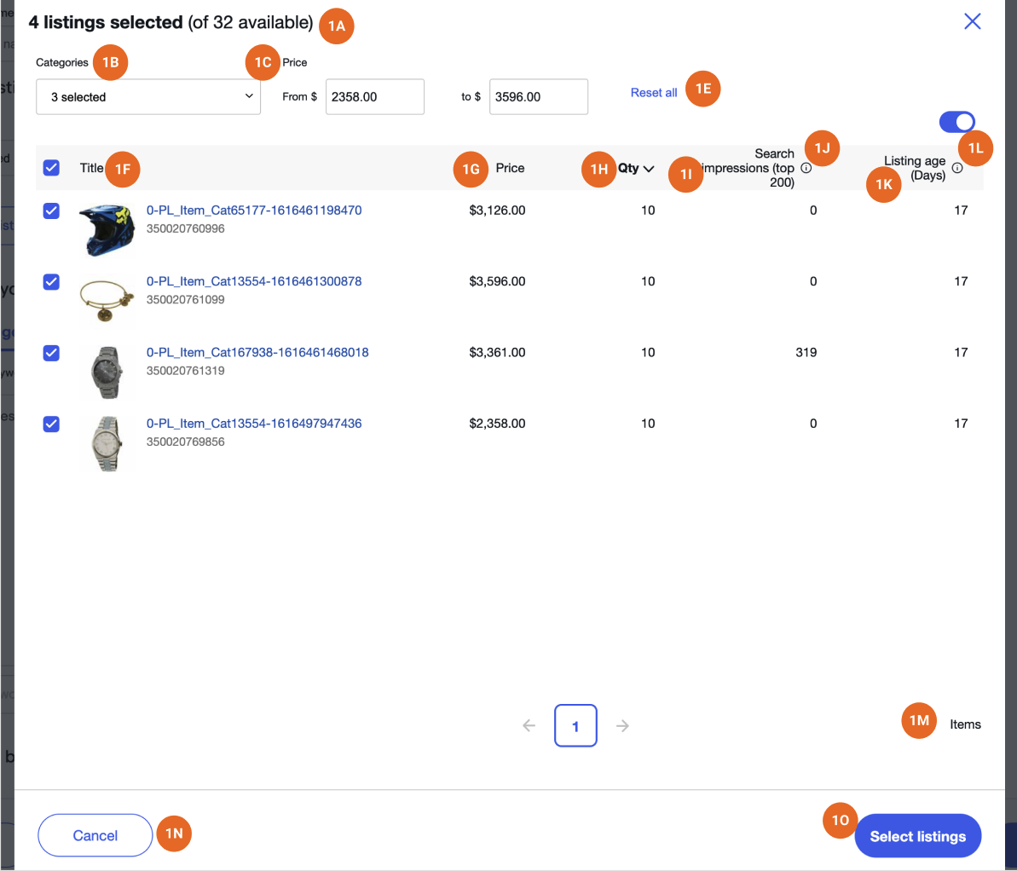

# ****Footer - Content****

|  |  |  |  |  |
| --- | --- | --- | --- | --- |
| **Position/Relevance** | **#** | **Mock Content** | **Final Content** | **Notes** |
| Button Text | 1 | Save and add ad group | Save |  |
| Button text | 2 | Review and launch | Review and launch |  |

# ****Footer - Image****

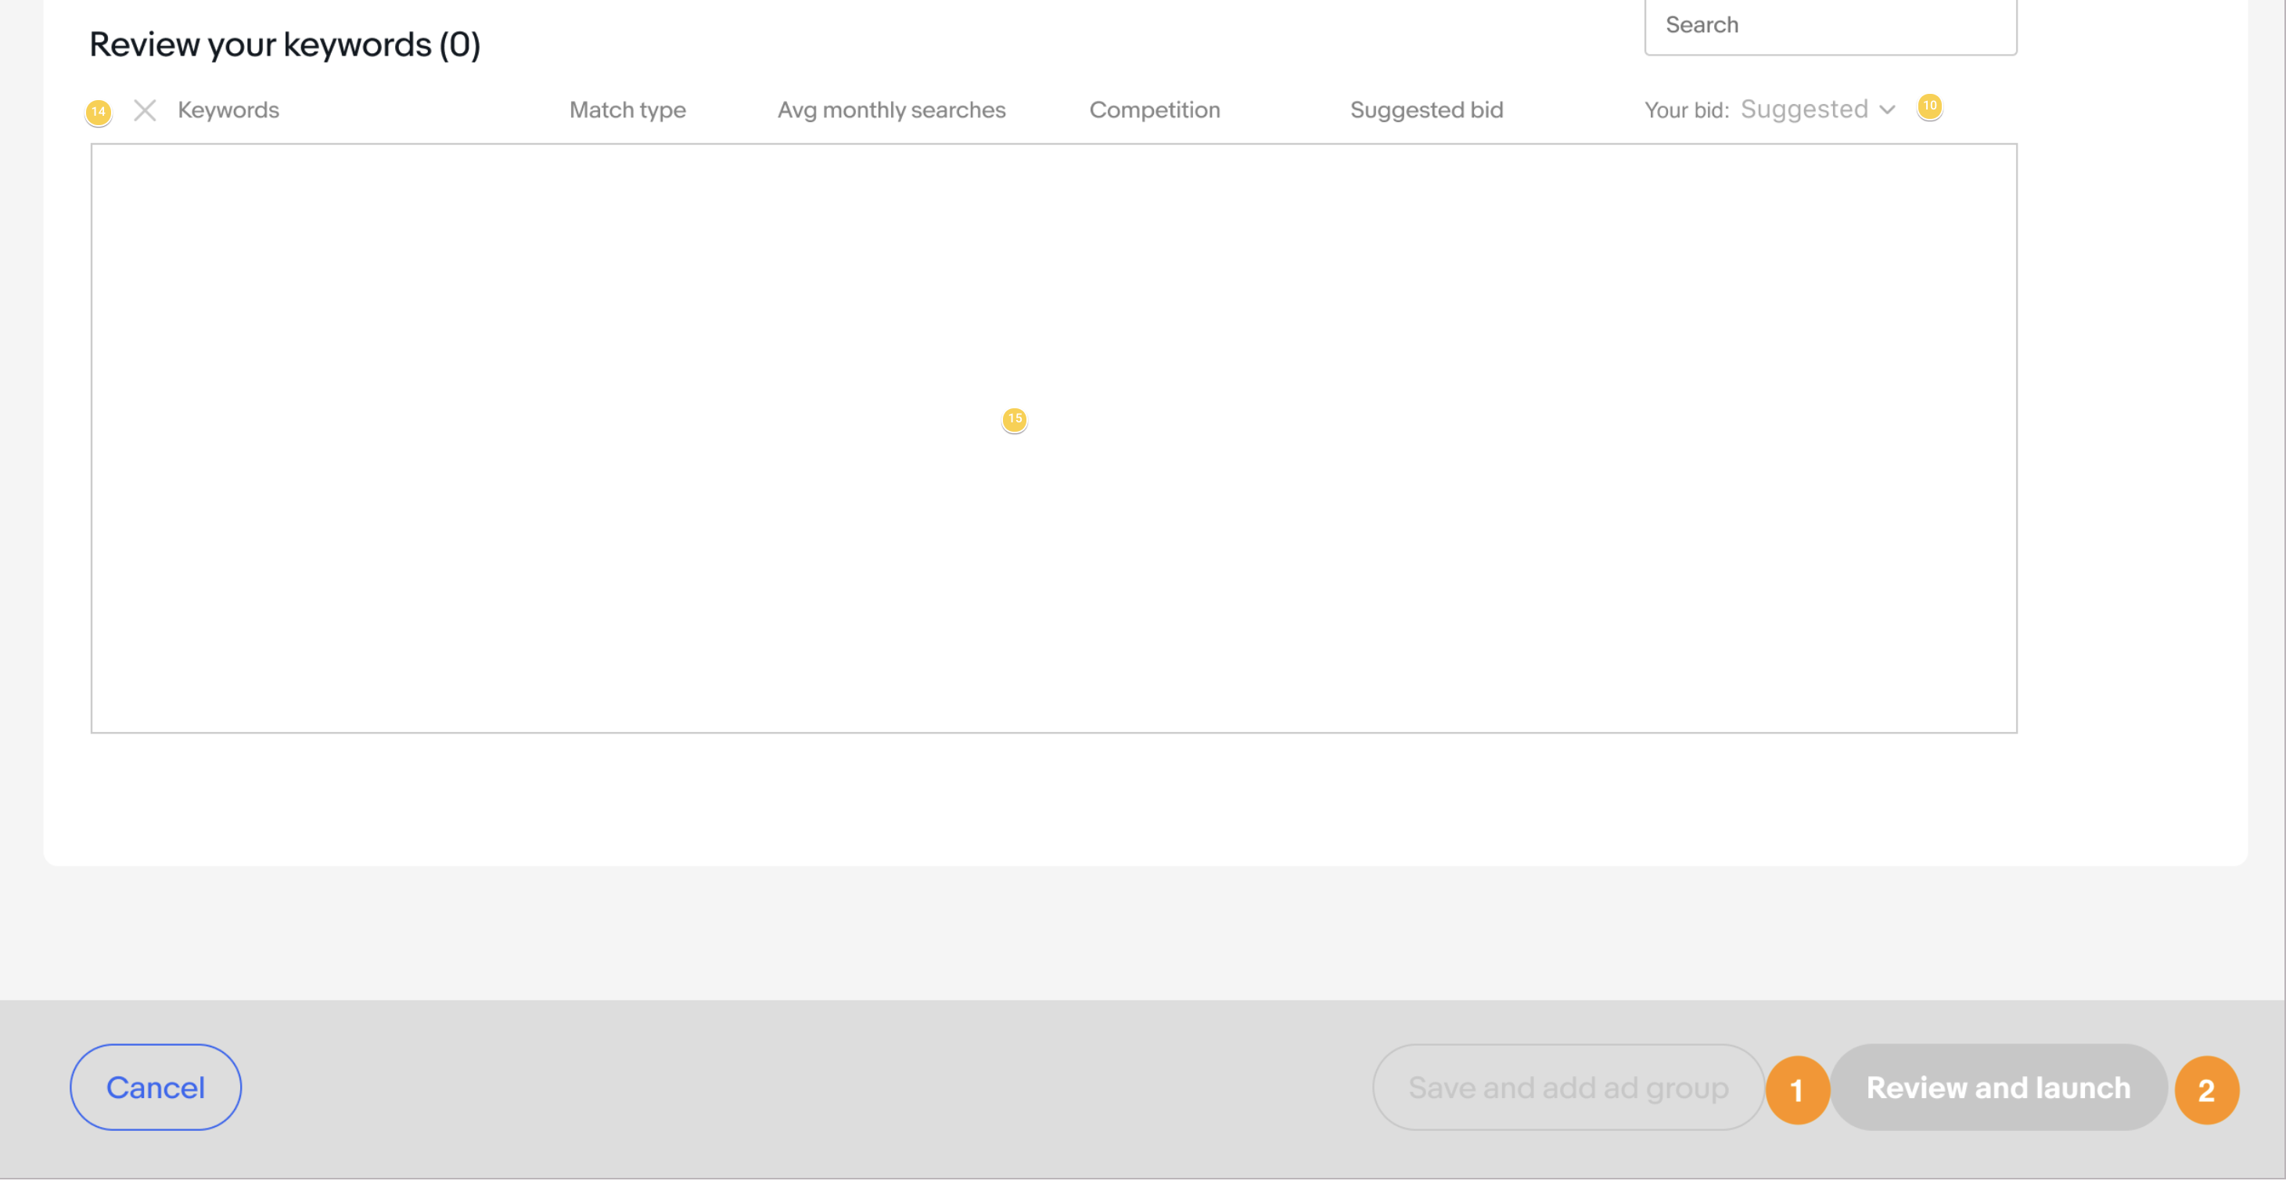

# ****Review Page - Content****

|  |  |  |  |  |
| --- | --- | --- | --- | --- |
| **Position/Relevance** | **#** | **Mock Content** | **Final Content** | **Notes** |
| Section Title | 1A | Review your campaign | Review your campaign |  |
| Section Option 1 | 1B | Cyber Week [ seller campaign name ] | [ seller campaign name ] |  |
| Section Option 2 | 1C | Edit | Edit | Takes sellers back to create flow for editing |
| Section Option 3 | 1D | Total listings | Total listings |  |
| Section Option 4 | 1E | Start date | Start date |  |
| Section Option 5 | 1F | End date | End date |  |
| Section Option 6 | 1G | Daily budget | Daily budget |  |
| Subsection Title | 1H | Your ad groups | Your ad groups |  |
| Subsection Option 1 | 1I | Ad group name | [ seller ad group 1 name ] |  |
| Subsection Option 2 | 1J | Edit | Edit | Takes sellers back to create flow for editing |
| Subsection Option 3 | 1K | Listings | Listings |  |
| Subsection Option 4 | 1L | Keywords | Keywords |  |
| Exit Window | 1M | Cancel | Cancel |  |
| TOS Agreement | 1N | By launching this campaign, you agree to the Terms of Service. | By launching this campaign, you agree to the Terms of Service. | Link to Terms of Service page |
| Confirm Changes | 1O | Launch campaign | Launch |  |

# ****Review Page - Image****

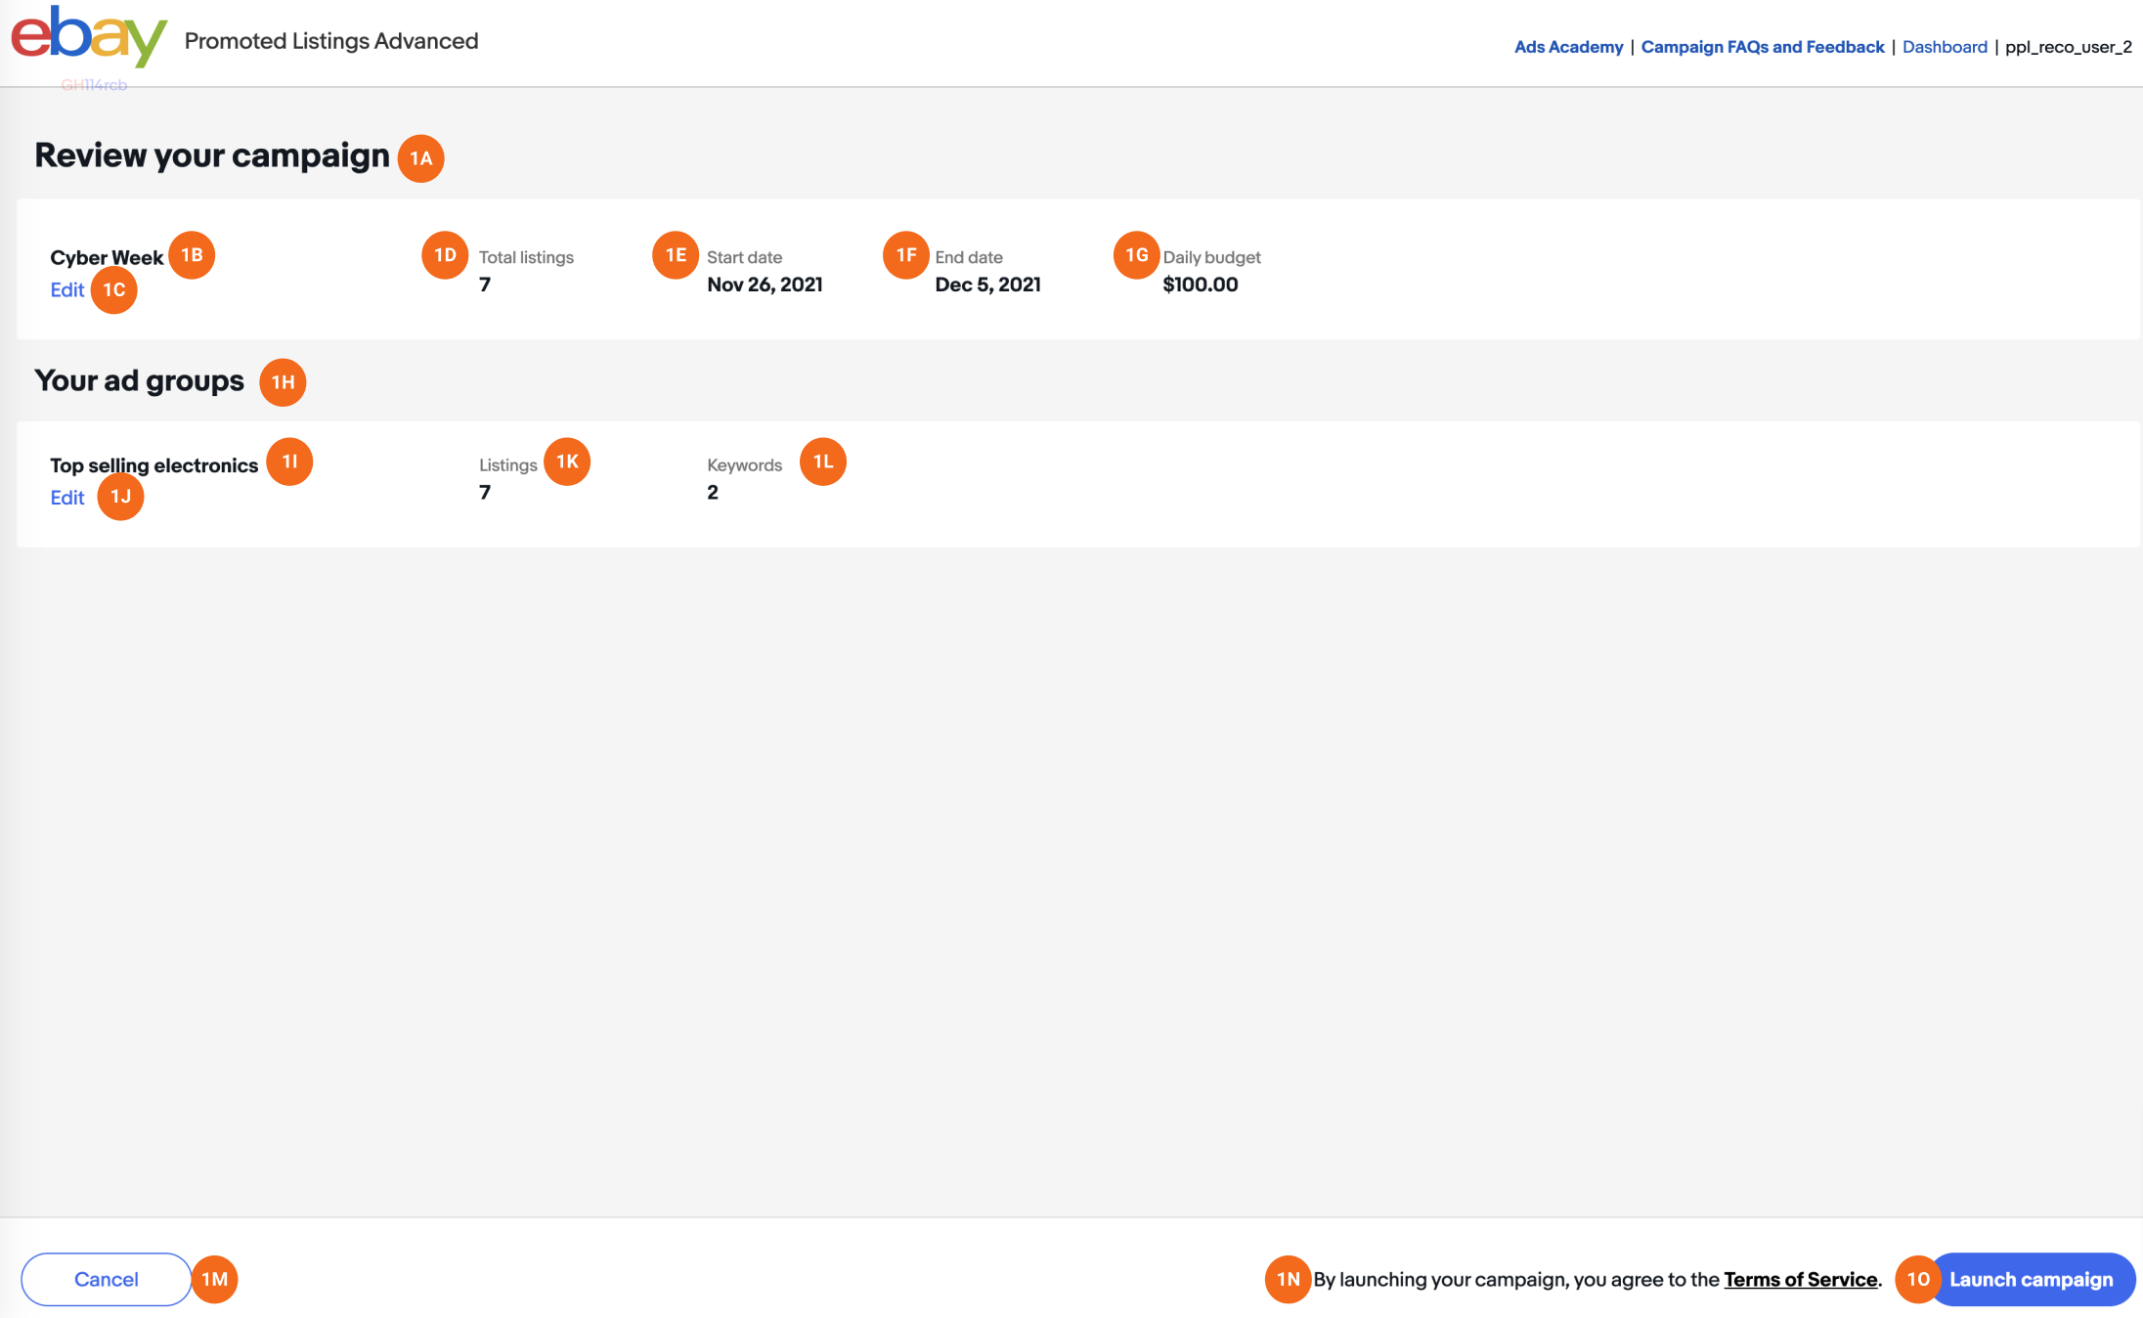

PLACE HOLDER